姓名：杲时雨
学号：2019116022
时间：2020.12.29
编号：4

Project: Class to Handle Large Numbers

（1）问题描述：
创建一个可以处理大整数值的类。用户应该能够输入一个非常大的数字（比如我们银河系或已知宇宙中的恒星数量），然后这个类应该能够存储这个数字，并允许这个类的两个实例彼此相减、相加、相乘或除法。其中一个操作的结果是large numbers类的另一个实例。一种方法是把一个大整数看作一系列数字，你可以把一个字符串看作一系列字符。然后，在执行各种操作时，可以分别处理这些数字中的每一个。首先尝试使用减法或加法法，因为这些方法应该是最容易实现的。

（2）设计：
UML类图：
ClassToHandleLargeNumbers类
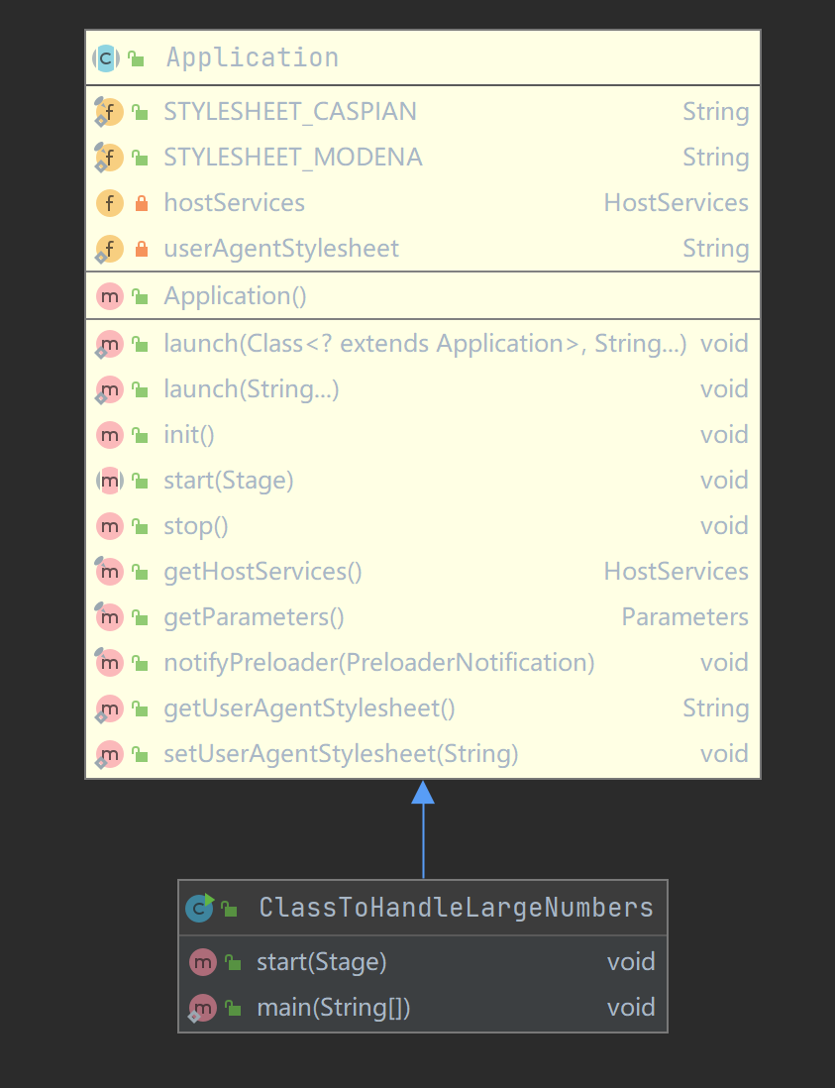
Bignumber类
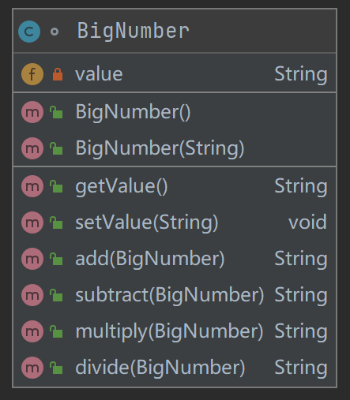

UI界面设计：
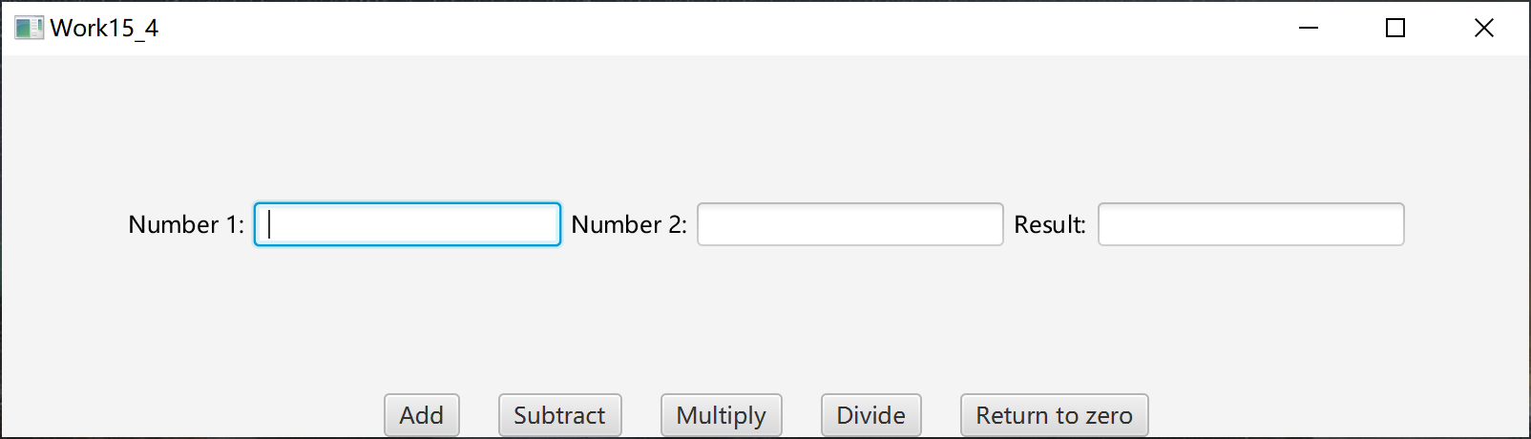

（3）代码：
import javafx.application.Application;
import javafx.geometry.Insets;
import javafx.geometry.Pos;
import javafx.scene.Scene;
import javafx.scene.control.Button;
import javafx.scene.control.TextField;
import javafx.scene.layout.BorderPane;
import javafx.scene.layout.HBox;
import javafx.scene.text.Text;
import javafx.stage.Stage;

public class ClassToHandleLargeNumbers extends Application {
public void start(Stage primaryStage) {
HBox textLine = new HBox();
HBox buttonLine = new HBox();
textLine.setAlignment(Pos.CENTER);
textLine.setPadding(new Insets(10, 10, 10, 10));
buttonLine.setAlignment(Pos.CENTER);
textLine.setSpacing(5);
buttonLine.setSpacing(20);
Text text1 = new Text("Number 1:");
Text text2 = new Text("Number 2:");
Text text3 = new Text("Result:");

TextField field1 = new TextField();
TextField field2 = new TextField();
TextField field3 = new TextField();
field3.setEditable(false);

Button addButton = new Button("Add");
Button subtractButton = new Button("Subtract");
Button multiplyButton = new Button("Multiply");
Button divideButton = new Button("Divide");
Button zeroButton = new Button("Return to zero");

textLine.getChildren().addAll(text1, field1, text2, field2, text3, field3);
buttonLine.getChildren().addAll(addButton, subtractButton, multiplyButton, divideButton, zeroButton);

BorderPane pane = new BorderPane();
pane.setCenter(textLine);
pane.setBottom(buttonLine);

Scene scene = new Scene(pane, 800, 200);
primaryStage.setTitle("Work15_4");
primaryStage.setScene(scene);
primaryStage.show();

addButton.setOnAction(e->{ //add按钮的事件处理器
BigNumber number1 = new BigNumber(field1.getText());
BigNumber number2 = new BigNumber(field2.getText());
String str = number1.add(number2);
field3.setText(str);
});

subtractButton.setOnAction(e->{ //subtract按钮的事件处理器
BigNumber number1 = new BigNumber(field1.getText());
BigNumber number2 = new BigNumber(field2.getText());
String str = number1.subtract(number2);
field3.setText(str);
});

multiplyButton.setOnAction(e->{ //multiply按钮的事件处理器
BigNumber number1 = new BigNumber(field1.getText());
BigNumber number2 = new BigNumber(field2.getText());
String str = number1.multiply(number2);
field3.setText(str);
});

divideButton.setOnAction(e->{ //divide按钮的事件处理器
BigNumber number1 = new BigNumber(field1.getText());
BigNumber number2 = new BigNumber(field2.getText());
String str = number1.divide(number2);
field3.setText(str);
});

zeroButton.setOnAction(e -> { //归零按钮的事件处理器
field1.setText("");
field2.setText("");
field3.setText("");

});
}

public static void main(String[] args) {
Application.launch(args);
}
}

//BigNumber是一个大数类，可计算无穷大的数字加减乘除
class BigNumber {
private String value;

public BigNumber() {
value = "0";
} //无参构造方法
public BigNumber(String value) {
this.value = value;
} //有参构造

public String getValue() {
return value;
}
public void setValue(String newValue) {
this.value = newValue;
}

public String add(BigNumber newNumber) { //加法方法
String result = "", tempOfString;
int number1, number2, remainder = 0, temp;
int length1 = this.value.length();
int length2 = newNumber.value.length();
int i, j;
int flag = 1;

if (this.value.contains("-") && !newNumber.value.contains("-")) { //如果number1数有“-”号的话，立马转换成number2-number1的形式
this.value = this.value.substring(1); //把-号截取掉
tempOfString = this.value; //交换number1和number2的位置
this.value = newNumber.value;
newNumber.value = tempOfString;
return this.subtract(newNumber); //采用number2-number1的方法
}
else if (!this.value.contains("-") && newNumber.value.contains("-")) { //如果number2有负号而number1没有，就转换成number1-number2
newNumber.value = newNumber.value.substring(1);
return this.subtract(newNumber);
}
else if (this.value.contains("-") && newNumber.value.contains("-")) {
this.value = this.value.substring(1);
newNumber.value = newNumber.value.substring(1);
length1--;
length2--;
flag = -1;
}

for (i = length1 - 1, j = length2 - 1; i >= 0 && j >= 0; i--, j--) {
number1 = (this.value.charAt(i) - '0'); //从最低为开始加
number2 = (newNumber.value.charAt(j) - '0');
temp = (number1 + number2 + remainder) % 10; //求本位应该放什么数字
result = temp + "" + result;
remainder = (number1 + number2 + remainder>= 10) ? 1 : 0; //进位的数字
}

if (i < 0 && j >= 0) { //解决剩余位数字的加法
while (j >= 0) {
number2 = (newNumber.value.charAt(j) - '0');
temp = (number2 + remainder) % 10;
result = temp + "" + result;
remainder = (number2 + remainder >= 10) ? 1 : 0;
j--;
}
}
else if (i >= 0 && j < 0) {
while (i >= 0) {
number1 = (this.value.charAt(i) - '0');
temp = (number1 + remainder) % 10;
result = temp + "" + result;
remainder = (number1 + remainder >= 10) ? 1 : 0;
i--;
}
}

if (remainder != 0) { //如果最后算的最高位不为零，就加在结果字符的开头
result = remainder + "" + result;
}

if (flag == -1) {
result = "-" + result;
}

return result;
}

public String subtract(BigNumber newNumber) { //减法操作，把大的数字设置成number1，小的数字设置成number2，然后进行从低位到到高位的减法运算
String result = "", tempOfString;
int number1, number2, remainder = 0, temp, count = 0, flag = 1;
int length1 = this.value.length();
int length2 = newNumber.value.length();
int i, j;

if (this.value.contains("-") && !newNumber.value.contains("-")) {
this.value = this.value.substring(1);
result = "-" + this.add(newNumber);
return result;
}
else if (newNumber.value.contains("-") && !this.value.contains("-")) {
newNumber.value = newNumber.value.substring(1);
return this.add(newNumber);
}
else if (newNumber.value.contains("-") && this.value.contains("-")) {
this.value = this.value.substring(1);
newNumber.value = newNumber.value.substring(1);
tempOfString = newNumber.value;
newNumber.value = this.value;
this.value = tempOfString;
length1 = this.value.length();
length2 = newNumber.value.length();
}

if (length1 < length2) {
tempOfString = newNumber.value;
newNumber.value = this.value;
this.value = tempOfString;
length1 = this.value.length();
length2 = newNumber.value.length();
flag = -1;
}
else if (length1 == length2) {
for (int k = 0; k < length1; k++) {
if (this.value.charAt(k) > newNumber.value.charAt(k)) {
break;
}
else if (this.value.charAt(k) < newNumber.value.charAt(k)) {
tempOfString = newNumber.value;
newNumber.value = this.value;
this.value = tempOfString;
flag = -1;
break;
}
count++;
}
}

for (i = length1 - 1, j = length2 - 1; i >= count && j >= count; i--, j--) {
number1 = (this.value.charAt(i) - '0');
number2 = (newNumber.value.charAt(j) - '0');
if (number1 - remainder < number2) {
temp = number1 - remainder - number2 + 10;
remainder = 1;
}
else {
temp = number1 - remainder - number2;
remainder = 0;
}
if (i != count || temp != 0)
result = temp + "" + result;
}

while (count == 0 && i >= 0) {
number1 = (this.value.charAt(i) - '0');
number2 = 0;
if (number1 - remainder < number2) {
temp = number1 - remainder - number2 + 10;
remainder = 1;
}
else {
temp = number1 - remainder - number2;
remainder = 0;
}
if (i != 0 || temp != 0)
result = temp + "" + result;
i--;
}
if (flag == -1)
result = "-" + result;
if (count == length1)
return "0";
else
return result;
}

public String multiply(BigNumber newNumber) { //采用了加法的相关操作，一位一位进行乘法运算，实际上就是将乘法分配为加法进行运算(以加法为基础)
String result = "0", tempOfString, mulSec = "";
int i, j;
int length1 = this.value.length();
int length2 = newNumber.value.length();
int flag = 1;

if (this.value.contains("-")) { //判断数字是否为-的操作
this.value = this.value.substring(1);
flag = -flag;
}
if (newNumber.value.contains("-")) {
newNumber.value = newNumber.value.substring(1);
flag = -flag;
}

if (this.value.equals("0") || newNumber.value.equals("0"))
return "0";
if (length1 < length2) {
tempOfString = this.value;
this.value = newNumber.value;
newNumber.value = tempOfString;
length1 = this.value.length();
length2 = newNumber.value.length();
}

for (i = newNumber.value.length() - 1; i >= 0; i--) {
String tempOfNumber = "0";
for (j = newNumber.value.charAt(i) - '0'; j > 0; j--) {
tempOfNumber = this.add(new BigNumber(tempOfNumber));
}
if (newNumber.value.charAt(i) != '0') {
tempOfNumber = tempOfNumber + mulSec;
}
mulSec = mulSec + "0";
result = new BigNumber(result).add(new BigNumber(tempOfNumber));
}

if (flag == -1) {
result = "-" + result;
}

return result;
}

public String divide(BigNumber newNumber) { //除法操作，就是每次都在number1数基础上减number2数，每减一次，结果result就加1，从而实现除法(以减法和加法为基础)
String result = "0";
String tempOfString, temp;
/*
this.value = this.value + ".0";
newNumber.value = newNumber.value + ".0";
BigDecimal number1 = new BigDecimal(this.value);
BigDecimal number2 = new BigDecimal(newNumber.value);
result = number1.divide(number2).toString();
return result;
*/
if (newNumber.value.equals("0"))
return "False Input";
else if (this.value.equals("0"))
return "0";

int flag = 1;
if (this.value.contains("-")) {
this.value = this.value.substring(1);
flag = -flag;
}
if (newNumber.value.contains("-")) {
newNumber.value = newNumber.value.substring(1);
flag = -flag;
}

for ( ; !this.subtract(newNumber).contains("-"); this.value = this.subtract(newNumber)) {
result = (new BigNumber(result)).add(new BigNumber("1"));
}
{
temp = this.value;
this.value = newNumber.value;
newNumber.value = temp;
}

if (this.value.equals("0")){
return result;
}
else {
double remainder = Double.parseDouble(this.value);
double divisor = Double.parseDouble(newNumber.value);
double tempOfResult = remainder / divisor;
tempOfString = tempOfResult + "";
tempOfString = tempOfString.substring(1);
result = result + tempOfString;
}

if (flag == -1) {
result = "-" + result;
}
return result;
}
}

（4）运行程序的屏幕截图：
加法：
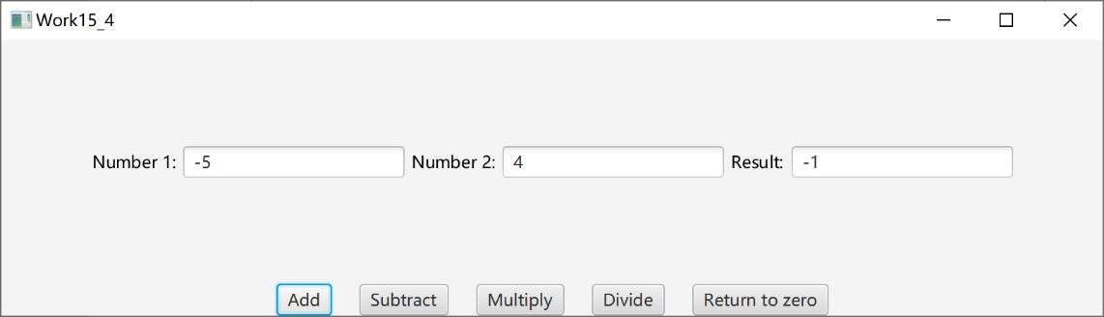

减法：
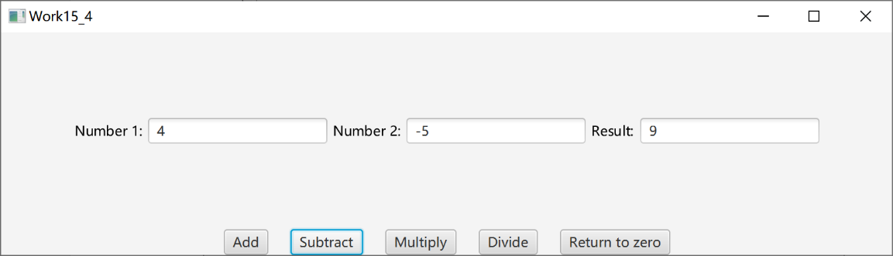

乘法：
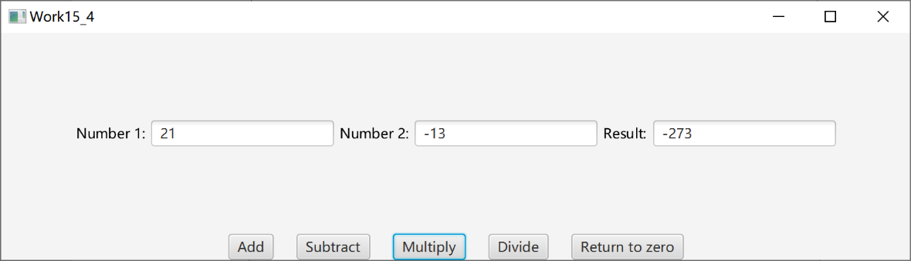

除法：
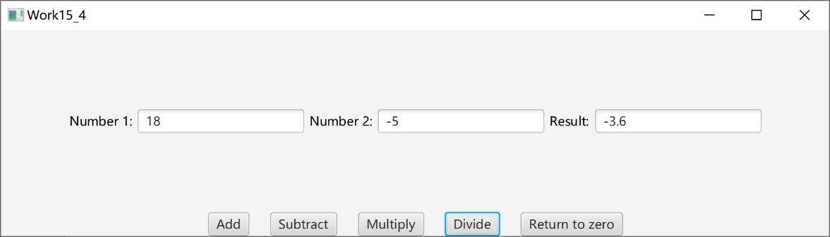

大数加法：
Number1：124444444444444444444444444222222222222222222333333333333333333333333333333
Number2：
999999999999999999999999999999999999999999992341342143
Result：
124444444444444444445444444222222222222222222333333333333333333325674675476
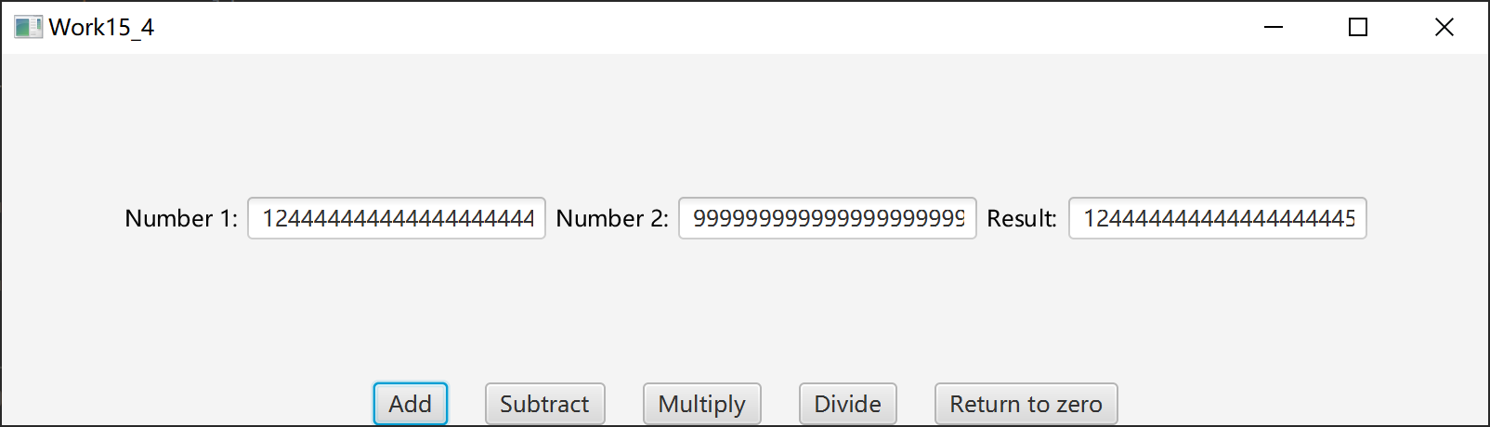

大数乘法：
Number1：
11111111111111111111111111111111111111111
Number2：
400000000000000000000000000000000000000000000
Result：
4444444444444444444444444444444444444444400000000000000000000000000000000000000000000
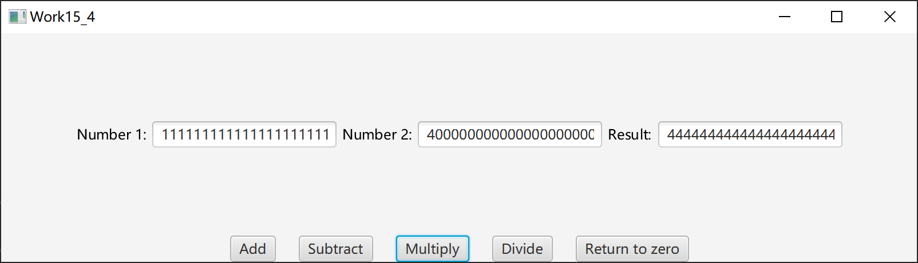

（5）自我评价
功能：
①本程序可用于天文数字的计算，由于采用了字符串计算形式，故计算数没有位数限制。
②本程序可用于负数的计算，可以承载各类合法数字的输入及计算，这使程序的鲁棒性较强。
③本程序包含归零化按钮，方便用户直接直接进行下次计算。

界面：
①界面由两个输入框和一个结果框构成，简单明了。
②计算按钮并排排列，方便计算。
③归零按钮放在计算按钮之后，方便操作。

错误提示：
①当输入的运算数不正确时，程序提示相关错误，提醒用户重新输入。
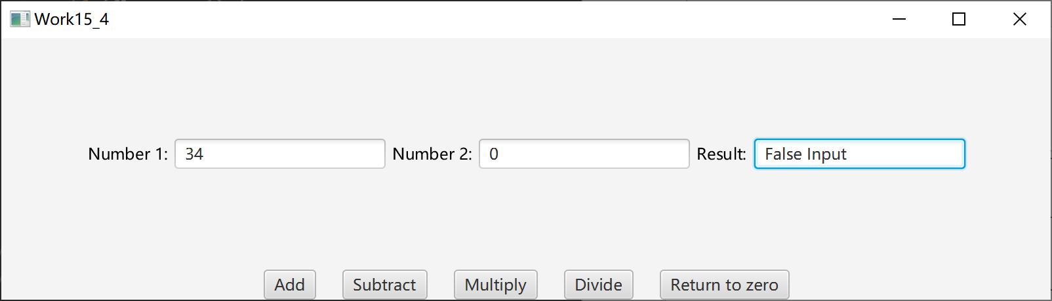

程序稳定性：
①支持正负数及0的运算，程序鲁棒性较强。
②程序设计在JavaFX平台框架下，运行时较稳定。

